FAKE NEWS DETECTION USING NLP

BATCH MEMBERS:

TEAM ID: proj-212171-Team2

TEAM NO: 2

REG.NO: 950621104104

PHASE 5 SUBMISSION DOCUMENT

PROJECT TITLE : FAKE NEWS DETECTION USING NLP

TOPIC: In this section the complete project and prepare it for submission



Introduction:

• We consume news through several mediums throughout the day in our daily routine, but sometimes it becomes difficult to decide which one is fake and which one is authentic.

• Every news that we consume is not real. If you listen to fake news it means you are collecting the wrong information from the world which can affect society because a person’s views or thoughts can change after consuming fake news which the user
perceives to be true.

• We will focus on text-baseqd news and try to build a model that will help us to identify if a piece of given
news is fake or real.

• NLP is a branch of data science that consists of systematic processes for analyzing, understanding, and deriving information from the text data in a smart and efficient manner.

Terminologies:

Fake news:
A sort of sensationalist reporting, counterfeit news embodies bits of information that might be lies and is, for the most part, spread through web-based media and other online media. This is regularly done to further or force certain kinds of thoughts or for false promotion of products and is frequently

The rapid spread of fake news has become a major issueworldwide
.
The spread of false and misleading news has led to significant social and economic consequences, impacting industries from finance to healthcare.

Misinformation and fake news can have a long-term impact, especially when people rely on accurate information to make critical decisions.

The need for detecting fake news has never been more crucial. Machine learning techniques can help us detect fake news efficiently and accurately.

Using natural language processing techniques, machine learning algorithms can accurately detect and categorize true and false new

DATASOURCE:A good data source for Fake news detection using NLP
learning should be accurate time, location.trueth,real news

Data link:
(https://www.kaggle.com/datasets/clmentbisaillon/fake-and-real-news-dataset)

FAKE.CSV



1.Text Cleaning:

This involves removing any unnecessary characters, punctuation, or special symbols from the text. You can also convert the text to lowercase to ensure consistency.

2. Tokenization:
This step involves breaking down the text into individual words or tokens.
This allows for easier analysis and processing of the text data.

3. Stop Word Removal:
Stop words are common words that don’t carry much meaning, such as “the”, ”is”, or “and”. Removing this words can help reduce noise in the data and improve the accuracy of the analysis.

4. Lemmatization or Stemming:
This step involves reducing words to their base or root form. For example, converting “running” to “run” to “cat”. This helps to consolidate similar words and improve the efficiency of the analysis.

5. Feature Extraction:
This transforming the text into numerical features that can be used for
analysis. Technique such as TF-IDF(Term Frequency-Inverse Document Frequency).

6. Vectorization:
Vectorization is a methodology in NLP to map words or phrases from vocabulary to a corresponding vector of real numbers which is used to find word predictions, word

Overview of the process:
The following is an overview of the process of building a house price prediction model by feature selection, model training and evaluation.

Prepare the data:
This includes cleaning the data, removing outliers, and handling missing values.

Perform feature selection:
This can be done using a variety of methods, such as correlation analysis, information gain, and recursive feature elimination.

Train the model:
The first step of NLP model training is to collect and prepare the data that the model will use to learn from. Depending on the task and the language, you may need different types and sources of data, such as text, audio, or images.

Evaluate the model:
There are two ways to evaluate language models in NLP:
Extrinsic evaluation
Intrinsic evaluation.
Intrinsic evaluation captures how well the model captures what it is supposed to capture, like probabilities.

Extrinsic evaluation (or task-based evaluation) captures how useful the model is in a particular task.

Deploy the model:
Model deployment involves making the model available to end users. Once the model is trained and validated, it is ready for deployment.
Real

Feature selection:
Feature Selection is the process where you automatically or manually select those features which contribute most to your prediction variable or output in which you are interested in.

Having irrelevant features in your data can decrease the accuracy of the models and make your model learn based on irrelevant features.



1.DESIGN THINKING AND PRESENT IN FORM OF DOCUMENT

- Empathize:

➢ Understand the needs and challenges of all stakeholders involved in the
earthquake prediction process
➢ Conduct interviews and surveys to gather insights on what users value in property valuation and what information is most critical for their decision-
making.

- Define:

➢ Clearly articulate the problem statement, such as "How might we predict
Fake news or real news more accurately and transparently using NLP?"
➢ Identify the key goals and success criteria for the project, such as increasing
prediction accuracy, reducing bias, or improving user trust in the valuation process.

- Ideate:

➢ Brainstorm creative solutions and data sources that can enhance the accuracy and transparency of fake news predictions.
➢ Encourage interdisciplinary collaboration to generate a wide range of ideas, including the use of alternative data, new algorithms, or improved visualization techniques.

4.Prototype:
➢ Create prototype machine learning models based on the ideas
generated during the idealization phase.
➢ Test and iterate on these prototypes to determine which approaches are most promising in terms of accuracy and usability.

5.Test:
➢ Gather feedback from users and stakeholders by testing them machine
learning models with real-world data and scenarios.
➢ Assess how well the models meet the defined goals and success
criteria, and make adjustments based on user feedback.

- Implement:

➢ Develop a production-ready machine learning solution for predicting fake news, integrating the best-performing algorithms and data sources.

➢ Implement transparency measures, such as model interoperability tools, to ensure users understand how predictions are generated.

- Evaluate:

➢ Continuously monitor the performance of the machine learning
model after implementation to ensure it remains accurate.

➢ Gather feedback and insights from users.

- Iterate:

➢ Apply an iterative approach to refine the machine learning model based on ongoing feedback and changing user needs.

➢ Continuously seek ways to enhance prediction accuracy,
transparency, and user satisfaction.

- Scale and Deploy:

➢ Once the machine learning model has been optimized and validated, deploy it .

➢ Ensure the model is accessible through user-friendly interfaces and integrates seamlessly into real estate workflows.

- Educate and Train:

➢ Provide training and educational resources to help users understand how the machine learning model works, what factors it considers, and its limitations.

➢ Foster a culture of data literacy among stakeholders to enhance trust in the technology.


2.DESIGN INTO INNOVATION

1. Data Collection:

Gather a comprehensive datasets that includes features such as latitude,longitude, magnitude, depth, others relevant variables.

2.Data Prepossessing:

Clean the data by handling missing values, outliers, and encoding
categorical variables. Standardize or normalize numerical features as

PROGRAM: TO CREATE A FAKE NEWS DETECTION USING NLP

FAKE NEWS DETECTION USING PYTHON

import numpy as np
import pandas as pd
import itertools
from sklearn.model_selection import train_test_split
from sklearn.feature_extraction.text import Transistorize
from sklearn.linear_model import PassiveAggressiveClassifier
from sklearn.metrics import accuracy_score, confusion_matrix

data location:

df=pd.read_csv(‘D:\fake news detection’)

The process of data cleaning and data analysis

df.shape
df.head()
labels=df.label
labels.head()
Data Cleaning
In [3]:
df.duplicated()
Out [3]:

#DataFlair - Split the datasets
x_train,x_test,y_train,y_test=train_test_split(df[&#39;text&#39;], labels, test_size=0.2,
random_state=7)

#DataFlair - Initialize a TfidfVectorizer
tfidf_vectorizer=TfidfVectorizer(stop_words=&#39;english&#39;, max_df=0.7)

#DataFlair - Fit and transform train set, transform test set
tfidf_train=tfidf_vectorizer.fit_transform(x_train)
tfidf_test=tfidf_vectorizer.transform(x_test)

DataFlair - Initialize a TfidfVectorizer
tfidf_vectorizer=TfidfVectorizer(stop_words=&#39;english&#39;, max_df=0.7)

#DataFlair - Fit and transform train set, transform test set
tfidf_train=tfidf_vectorizer.fit_transform(x_train)
tfidf_test=tfidf_vectorizer.transform(x_test)

pac=PassiveAggressiveClassifier(max_iter=50)
pac.fit(tfidf_train,y_train)

#DataFlair - Predict on the test set and calculate accuracy
y_pred=pac.predict(tfidf_test)
score=accuracy_score(y_test,y_pred)
print(f&#39;Accuracy: {round(score*100,2)}%&#39;)

#DataFlair - Build confusion matrix
confusion_matrix(y_test,y_pred, labels=[&#39;FAKE&#39;,&#39;REAL&#39;])

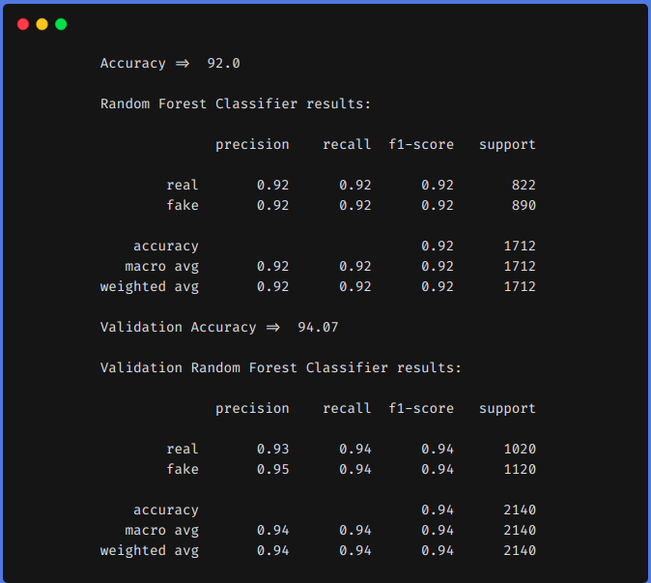

1.Number of Characters
Count the number of characters present in a tweet.def count_chars(text):
return len(text)

2. Number of words
Count the number of words present in a tweet.
def count_words(text):
return len(text.split())

3. Number of capital characters
Count the number of capital characters present in a tweet.

4. Number of capital words
Count the number of capital words present in a tweet.
def count_capital_words(text):
return sum(map(str.isupper,text.split()))

5. Count the number of punctuations
In this function, we return a dictionary of 32 punctuation with the counts, which can be used as separate features, which I will discuss in the next
section.

def count_punctuations(text):
punctuations=&#39;!&quot;#$%&amp;&#39;()*+,-./:;&lt;=&gt;?@[\]^_`{|}~&#39; d=dict()

for i in punctuations:
d[str(i)+&#39; count&#39;]=text.count(i)
return d

6. Number of words in quotes
The number of words in the single quotation and double quotation.
def count_words_in_quotes(text):
x = re.findall(&quot;&#39;.&#39;|&quot;.&quot;&quot;, text)
count=0
if x is None:
return 0
else:
for i in x:
t=i[1:-1]
count+=count_words(t)
return count
Reading train, validation, and test set
using pandas.
train = pd.read_csv(&quot;train.csv&quot;)
val = pd.read_csv(&quot;validation.csv&quot;)
test = pd.read_csv(testWithLabel.csv&quot;)

# For this task we will combine the train and validation
dataset and then use
# simple train test split from sklern.
df = pd.concat([train, val])
df.head()

Applying the above-defined feature extraction on train
and test set.
df[&#39;char_count&#39;] = df[&quot;tweet&quot;].apply(lambda
x:count_chars(x))
df[&#39;word_count&#39;] = df[&quot;tweet&quot;].apply(lambda
x:count_words(x))
df[&#39;sent_count&#39;] = df[&quot;tweet&quot;].apply(lambda
x:count_sent(x))
df[&#39;capital_char_count&#39;] = df[&quot;tweet&quot;].apply(lambda
x:count_capital_chars(x))
df[&#39;capital_word_count&#39;] = df[&quot;tweet&quot;].apply(lambda
x:count_capital_words(x))
df[&#39;quoted_word_count&#39;] = df[&quot;tweet&quot;].apply(lambda
x:count_words_in_quotes(x))
df[&#39;stopword_count&#39;] = df[&quot;tweet&quot;].apply(lambda
x:count_stopwords(x))

df[&#39;unique_word_count&#39;] = df[&quot;tweet&quot;].apply(lambda
x:count_unique_words(x))
df[&#39;htag_count&#39;] = df[&quot;tweet&quot;].apply(lambda
x:count_htags(x))
df[&#39;mention_count&#39;] = df[&quot;tweet&quot;].apply(lambda
x:count_mentions(x))
df[&#39;punct_count&#39;] = df[&quot;tweet&quot;].apply(lambda
x:count_punctuations(x))
df[&#39;avg_wordlength&#39;] = df[&#39;char_count&#39;]/df[&#39;word_count&#39;]
df[&#39;avg_sentlength&#39;] = df[&#39;word_count&#39;]/df[&#39;sent_count&#39;]
df[&#39;unique_vs_words&#39;] =
df[&#39;unique_word_count&#39;]/df[&#39;word_count&#39;]
df[&#39;stopwords_vs_words&#39;] =
df[&#39;stopword_count&#39;]/df[&#39;word_count&#39;]
# SIMILARLY YOU CAN APPLY THEM ON TEST
SET
We will create a DataFrame from the dictionary
returned by the “punct_count” function and then
merge it with the main dataset.
df_punct = pd.DataFrame(list(df.punct_count))
test_punct = pd.DataFrame(list(test.punct_count))

# Merging pnctuation DataFrame with main
DataFrame
df = pd.merge(df, df_punct, left_index=True,
right_index=True)

test = pd.merge(test, test_punct,left_index=True,
right_index=True)
# We can drop &quot;punct_count&quot; column from both df and
test DataFrame
df.drop(columns=[&#39;punct_count&#39;],inplace=True)
test.drop(columns=[&#39;punct_count&#39;],inplace=True)
df.columns

Result comparison:
For comparison, we first trained our model on
the above dataset by using features engineering
techniques and then without using feature
engineering techniques.
In both approaches, we pre-processed the
dataset using the same method as described above and TF-IDF was used in both approachesfor encoding the text data. You can use whatever encoding techniques you want to use like
word2vec, glove, etc.

1. Without using Feature Engineering techniques

2. Using Feature Engineering techniques From the above results, we can see that feature engineering techniques helped us to
increase our f1 from 0.90 to 0.92 in the train set and from 0.90 to 0.94 in the test set.

Model training:
The first step of NLP model training is to collect and prepare the data that the model will use to learn from. Depending on the task and the language, you may need different types and
sources of data, such as text, audio, or images.

Polynomial Recression:
A simple linear regression algorithm only works when the relationship between the data is linear. But suppose we have non-linear data, then linear regression will not be able to
draw a best-fit line. Simple regression analysis fails in such conditions.

Import numpyas np
import matplotlib.pyplot as plt
from sklearn.model_selection import train_test_split
from sklearn.linear_model import LinearRegression
from sklearn.preprocessing import PolynomialFeatures
from sklearn.metrics import r2_score
plt.plot(x_train, lr.predict(x_train), color=&quot;r&quot;)
plt.plot(X, y, &quot;b.&quot;)

plt.xlabel(&quot;X&quot;)
plt.ylabel(&quot;Y&quot;)
plt.show()

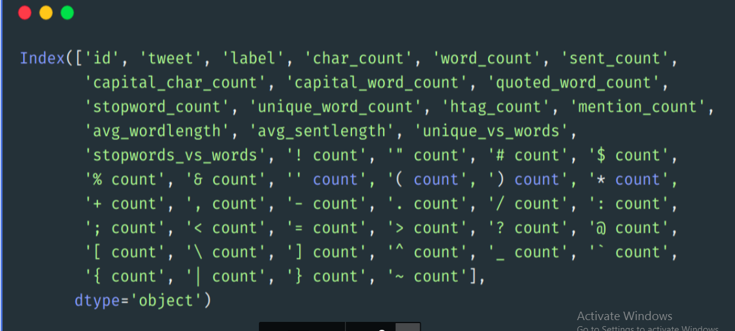

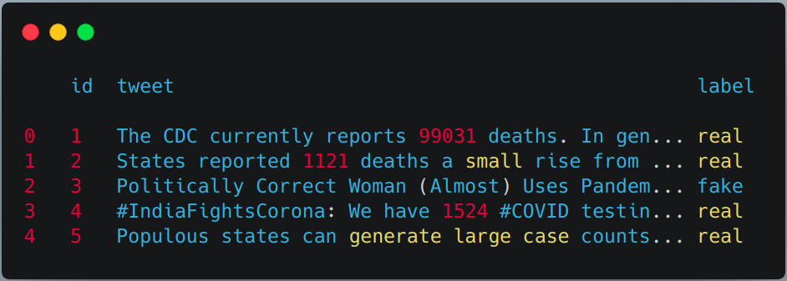

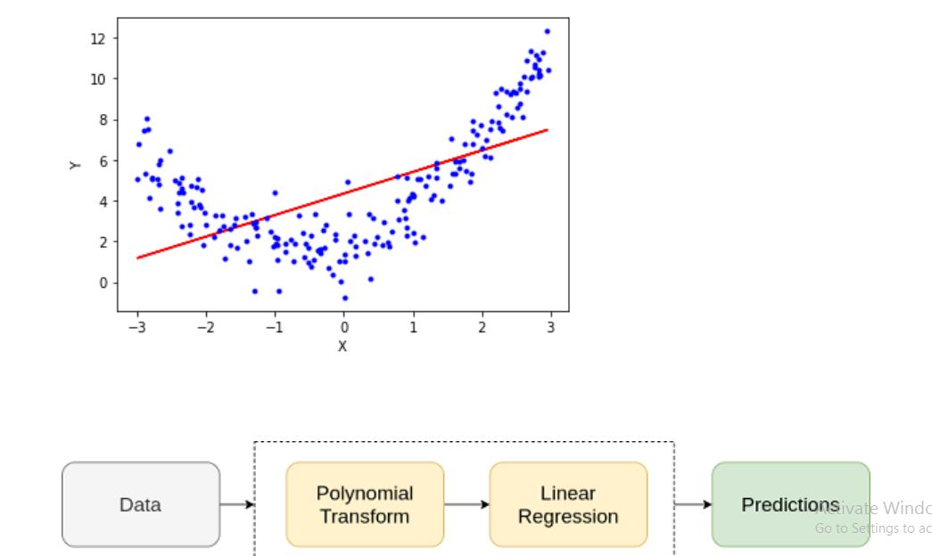

XGBoost Regressor:

import numpy as np
import pandas as pd
import xgboost as xg
from sklearn.model_selection import train_test_split

from sklearn.metrics import mean_squared_error
dataset = pd.read_csv(&quot;boston_house.csv&quot;)
X, y = dataset.iloc[:, :-1], dataset.iloc[:,
train_X, test_X, train_y, test_y = train_test_split(X, y,
test_size = 0.3, random_state = 123)
xgb_r = xg.XGBRegressor(objective =&#39;reg:linear&#39;,
n_estimators = 10, seed = 123)

xgb_r.fit(train_X, train_y)

pred = xgb_r.predict(test_X)

rmse = np.sqrt(MSE(test_y, pred))
print(&quot;RMSE : % f&quot; %(rmse))

Output:
129043.2314
# Classifier - Algorithm - SVM

# fit the training dataset on the classifier
SVM = svm.SVC(C=1.0, kernel=&#39;linear&#39;, degree=3, gamma=&#39;auto&#39;)
SVM.fit(Train_X_Tfidf,Train_Y)# predict the labels on validation
dataset
predictions_SVM = SVM.predict(Test_X_Tfidf)
# Use accuracy_score function to get the accuracy
print(&quot;SVM Accuracy Score -&gt;
&quot;,accuracy_score(predictions_SVM, Test_Y)*100)

Output:
SVM Accuracy Score -&gt; 84.6%

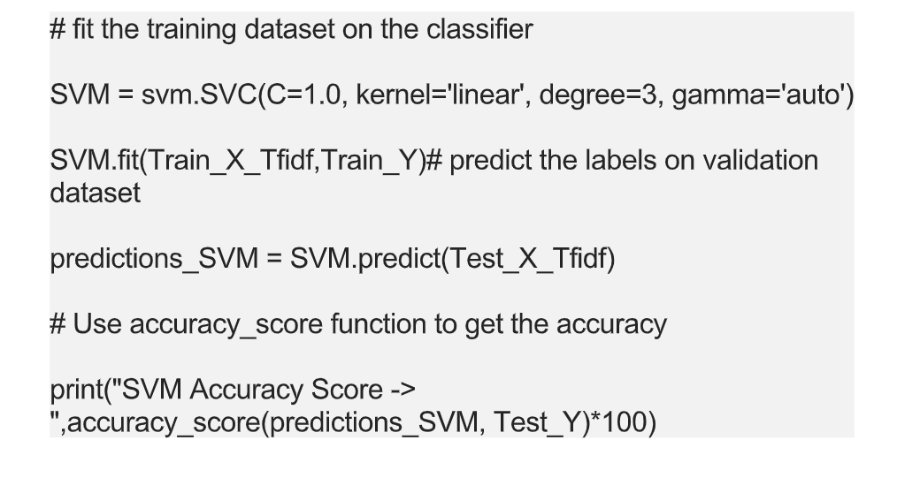

Elastic Net:

class ElasticRegression() :
def __init__( self, learning_rate, iterations, l1_penality, l2_penality ) :
self.learning_rate = learning_rate
self.iterations = iterations
self.l1_penality = l1_penality
self.l2_penality = l2_penality
def fit( self, X, Y ) :
self.m, self.n = X.shape

self.W = np.zeros( self.n )
self.b = 0
self.X = X
self.Y = Y
for i in range( self.iterations ) :
self.update_weights()
return self
def update_weights( self ) :
Y_pred = self.predict( self.X )
dW = np.zeros( self.n )
for j in range( self.n ) :
if self.W[j] &gt; 0 :
dW[j] = ( - ( 2 * ( self.X[:,j] ).dot( self.Y - Y_pred ) ) +
self.l1_penality + 2 * self.l2_penality * self.W[j] ) / self.m
else :
dW[j] = ( - ( 2 * ( self.X[:,j] ).dot( self.Y - Y_pred ) )
- self.l1_penality + 2 * self.l2_penality * self.W[j] ) / self.

db = - 2 * np.sum( self.Y - Y_pred ) / self.m
self.W = self.W - self.learning_rate * dW
self.b = self.b - self.learning_rate * db
return self
def predict( self, X ) :
return X.dot( self.W ) + self.b
def main() :
df = pd.read_csv( &quot;salary_data.csv&quot;
X = df.iloc[:,:-1].values
Y = df.iloc[:,1].values
X_train, X_test, Y_train, Y_test = train_test_split( X, Y,
test_size = 1/3, random_state = 0 )
model = ElasticRegression( iterations = 1000,
learning_rate = 0.01, l1_penality = 500, l2_penality = 1 )
model.fit( X_train, Y_train )
Y_pred = model.predict( X_test )
print( &quot;Predicted values &quot;, np.round( Y_pred[:3], 2 ) )
print( &quot;Real values &quot;, Y_test[:3] )

print( &quot;Trained W &quot;, round( model.W[0], 2 ) )
print( &quot;Trained b &quot;, round( model.b, 2 ) )
plt.scatter( X_test, Y_test, color = &#39;blue&#39; )
plt.plot( X_test, Y_pred, color = &#39;orange&#39; )
plt.title( &#39;Salary vs Experience&#39; )
plt.xlabel( &#39;Years of Experience&#39; )
plt.ylabel( &#39;Salary&#39; )
plt.show()
if __name__ == &quot;__main__&quot; :
main()

Output:
Predicted values [ 40837.61 122887.43 65079.6 ]
Real values [ 37731 122391 57081]
Trained W 9323.84
Trained b 26851.84


Necessary step to follow:

Import Libraries:

Start by importing the necessary libraries:

Program:
Import pandas as pd
Import numpy as np
from sklearn. model_ selection import train_ test_ split
from sklearn. preprocessing import StandaredScaler
plt.style.use('Solarize_Light2')

%matplotlib inline

Load the Dataset:
Load the dataset into a pandas DataFrame.
Program:
df=pd.read_csv('fake-news/train.csv')
df.head()

Output:

id | title | author | text | Label
0 | 0 | House Dem Aide: We Didn’t Even See Comey’s Let... | Darrell Lucus | House Dem Aide: We Didn’t Even See Comey’s Let... | 1
1 | 1 | FLYNN: Hillary Clinton, Big Woman on Campus - ... | Daniel J. Flynn | Ever get the feeling your life circles the rou... | 0
2 | 2 | Why the Truth Might Get You Fired | Consortiumnews.com | Why the Truth Might Get You Fired October 29, ... | 1
3 | 3 | 15 Civilians Killed In Single US Airstrike Hav... | Jessica Purkiss | Videos 15 Civilians Killed In Single US Airstr... | 1
4 | 4 | Iranian woman jailed for fictional unpublished... | Howard Portnoy | Print \nAn Iranian woman has been sentenced to... | 1

Program:
df.shape()

output:
(20800, 5)

Program:
df.isnull().sum()
Output:
id 0
title 558
author 1957
text 39
label 0
dtype: int64

Program:

df.dropna(inplace =True)
df.isna().sum()

Output:

id 0
title 0
author 0
text 0
label 0
dtype: int64

dataset.info()

Output :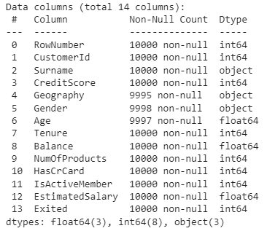

Data Preprocessing:

dataset.isnull().any()

Output :
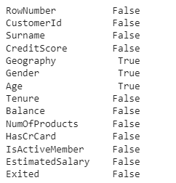

The benefits of a bar plot are that it is an excellent tool to observe the values of a few number of data points but want to present the general trend.

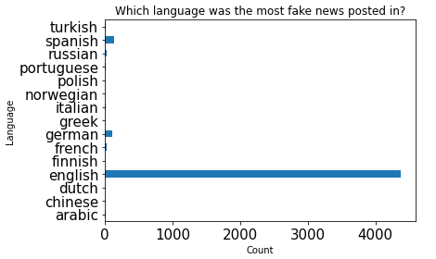
As the above plot shows, the main language represented in the dataset was English which was the main outlier with about 4507 data points.The rest of the languages had a fairly even distribution among them.
Program:
plt.figure(figsize=(12,))
sns.heatmap(dataset.corr(),
cmap='BrBG',
fmt='.2f',
linewidths=2,
annot=True)
Output :
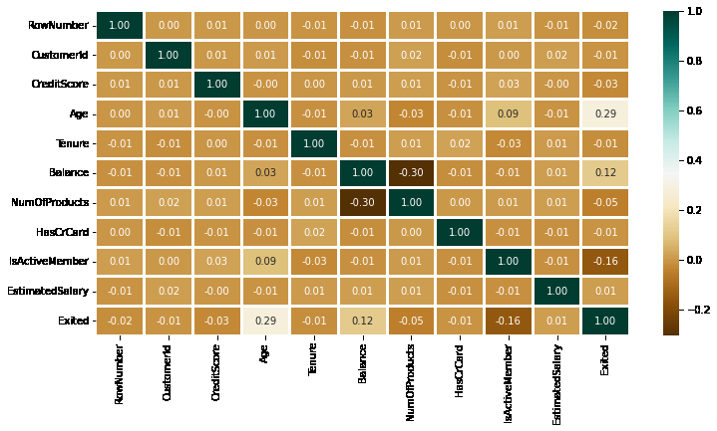
Program:

lis2 = ['Geography', 'Gender']
plt.subplots(figsize=(10, 5))
index = 1
for col in lis2:
y = dataset[col].value_counts()
plt.subplot(1, 2, index)
plt.xticks(rotation=90)
sns.barplot(x=list(y.index), y=y)
index += 1
Output :

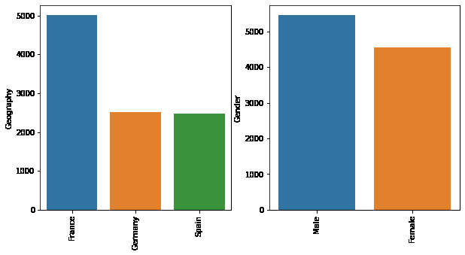

Logistic Regression:

Logistic regression is a data analysis technique that uses mathematics to find the relationships between two data factors.

It then uses this relationship to predict the value of one of those factors based on the other. The prediction usually has a finite number of outcomes, like yes or no.

Based on the analysis done, it was observed that logistic regression model achieved high accuracy, precision, recall, and F1 score in classifying news content as real or fake when compared with K-Nearest Neighbour (KNN), Passive Aggressive classi er and Naïve Bayes classi er.

Program:

from sklearn.linear_model import LogisticRegression

logreg = LogisticRegression()

logreg.fit(x_train, y_train)

Accuracy = logreg.score(x_test, y_test)

print(Accuracy*100)

Output:

Accuracy: 91.73%

Naïve baise:

A probabilistic model known as the Naive Bayes classifier makes predictions based on the likelihood that particular occurrences will occur.

The events are the classes or categories to which news articles can be classified, and the features are the words or other characteristics of the articles.

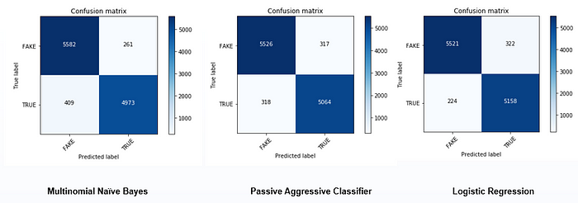

Program:

from sklearn.naive_bayes import MultinomialNB

classifier = MultinomialNB()

classifier.fit(X_train, y_train)

Output:
MultinomialNB()

Program:
y_pred = classifier.predict(X_test)
y_pred

Output:
array(['0', '0', '0', ..., '0', '0', '0'], dtype='<U1')

Program:
from sklearn import metrics

metrics.accuracy_score(y_test, y_pred)

Output:
0.9015748031496063

Decision Tree:

Decision trees are used to extract relevant features from the text data, and Ada boost is employed to enhance the performance of the decision trees.

The proposed method is evaluated on a dataset of news articles, and the results demonstrate its effectiveness in detecting fake news.

Program:

from sklearn.tree import DecisionTreeClassifier

clf = DecisionTreeClassifier()

clf.fit(x_train, y_train)

Accuracy = clf.score(x_test, y_test)

print(Accuracy*100)

Output:
Accuracy: 80.49%
Program:(Real values)
feature_names = cv.get_feature_names()

sorted(zip(classifier.coef_[0],feature_names),reverse=True)[0:20]

Output:

[(-3.9914839716490507, 'trump'),
(-4.279898913316484, 'hillari'),
(-4.348158915587783, 'clinton'),
(-4.88335015151613, 'elect'),
(-5.184527705442797, 'new'),
(-5.23658406739885, 'comment'),
(-5.3201316376692915, 'video'),
(-5.349607455802245, 'us'),
(-5.388828168955526, 'hillari clinton'),
(-5.406765869642194, 'war'),
(-5.429650163475781, 'fbi'),
(-5.45307043768388, 'email'),
(-5.4722097778945775, 'vote'),
(-5.579181897446745, 'world'),
(-5.579181897446745, 'obama'),
(-5.755072563910409, 'russia'),
(-5.828194828739372, 'donald'),
(-5.835115271583946, 'day'),
(-5.835115271583946, 'america'),
(-5.870454638029255, 'say')]

Program:(Fake values)
eature_names = cv.get_feature_names()

sorted(zip(classifier.coef_[0],feature_names),reverse=True)[-20:]
Output:

[(-10.804928571159946, 'american new'),
(-10.804928571159946, 'american breitbart'),
(-10.804928571159946, 'america new york'),
(-10.804928571159946, 'america new'),
(-10.804928571159946, 'america breitbart'),
(-10.804928571159946, 'amazon'),
(-10.804928571159946, 'ali'),
(-10.804928571159946, 'aleppo new york'),
(-10.804928571159946, 'aleppo new'),
(-10.804928571159946, 'agenda breitbart'),
(-10.804928571159946, 'age new york'),
(-10.804928571159946, 'age new'),
(-10.804928571159946, 'advis new york'),
(-10.804928571159946, 'advis new'),
(-10.804928571159946, 'advic'),
(-10.804928571159946, 'act new york'),
(-10.804928571159946, 'act new'),
(-10.804928571159946, 'abus new york'),
(-10.804928571159946, 'abus new'),
(-10.804928571159946, 'abroad')]

The top 10 key features in predicting fake news are shown below.
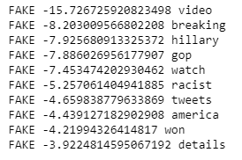
The top 10 key features in predicting true news are shown below.
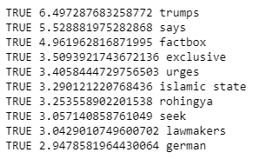

In most of the top fake and true news, only unigrams are present while in case of true news one bigram feature is also present.
Process:
Most text and documents contain many terms that are redundant for text classification, such as stop words, misspellings, slangs, and so on.
Hence, data pre-processing has to be done before the data is sent to the classification models.
After that, the dataset's dimensionality is decreased in order to save time and storage space. When the dimensions are reduced, it becomes easier to visualise.
The data is then used to train classification models, which can be used to predict whether or not the presented data is fraudulent.
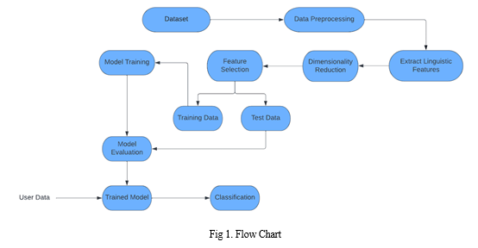
NLP Techniques :

We area unit exploitation Pos-tagging and TF-IDF for word frequency scores that attempt to highlight words that area unit a lot of fascinating, e.g., frequent in a very document however not across documents.

Pos-tagging could be a method to price the words in text format for a selected a part of a speech supported its definition and context. it's chargeable for text reading in a very language and distribution some specific token (Parts of Speech) to every word.

The TfIdf-Vectorizer can tokenize documents, learn the vocabulary and inverse document frequency weightings, and permit you to cypher new documents. whereas coaching the dataset this is often important step.

Formula(Algorithm): TF-IDF = TF(t,d) * IDF(t) ‘ TF’ stands for term frequency and ‘IDF’ stands for Inverse document frequency ,in this ‘t’ is a term frequency that is number of times t appears in a doc,’d’. IDF is calculated by : log[1+n/1+df(d,t)]+1

Exploratory Data Analysis:


Exploratory Data Analysis(EDA) is the process of exploring data, generating insights, testing hypotheses, checking assumptions and revealing underlying hidden patterns in the data.
Performing thorough exploratory data analysis (EDA) and cleaning the dataset are not only essential steps, but also a great opportunity to lay the foundation for a strong machine learning model.

Advantage
Machine learning techniques have revolutionized how we detect false news, offering numerous benefits over traditional fact-checking approaches. Here are some advantages of using machine learning for false news detection.
Scalability
ML algorithms can analyze vast data and identify patterns to detect false news. They can handle large datasets in real time, which is essential for monitoring news feeds and social media platforms where new content is generated continuously. This scalability allows the algorithm to keep up with the pace of information production and identify false news as soon as it appears.
Speed
Speed is critical when it comes to detecting online fake news. ML algorithms can process a vast amount of data quickly, enabling the system to immediately detect false news. The quicker the automatic detection is, the less harm the false news can cause. The algorithm can also be trained to prioritize certain types of true and false news online, enabling it to focus on the most relevant information.
Accuracy
One of the critical advantages of machine learning is its ability to learn from past data and improve its accuracy over time. Training the algorithm with labeled data allows it to recognize patterns in the text and images that indicate false news. The algorithm can also be updated regularly, ensuring it stays up-to-date with the latest types of false news.
Consistency
ML algorithms provide a consistent approach to false news detection. Unlike humans, ML algorithms make decisions based on data and patterns, whose biases, emotions, and personal opinions can influence them. This consistency ensures that the algorithm makes the same decision when faced with the same data, reducing the risk of false positives and negatives.

Cost-effective
False news detection using machine learning is more cost-effective than traditional fact-checking methods. Hiring a team of fact-checkers to review all the news content generated daily would be an expensive and time-consuming process. ML algorithms can, however, process large amounts of data quickly and accurately without human intervention.

Conclusion:
We have classified our news data using three classification models. We have analysed the performance of the models using accuracy and confusion matrix. But this is only a beginning point for the problem.
There are advanced techniques like BERT, GloVe and ELMo which are popularly used in the field of NLP. If you are interested in NLP, you can work forward with these techniques.

